September 25, 2025

The Honorable James Comer
Chairman
Committee on Oversight and Government Reform
2157 Rayburn House Office Building
Washington, D.C. 20515

Dear Chairman Comer:

As a member of the Committee on Oversight and Government Reform, I am writing to urge you hold an oversight hearing to examine reports that White House “Border Czar” Tom Homan accepted a $50,000 cash payment from undercover federal agents in exchange for his promise to assist in securing future border security contracts from the Federal Government. The Committee should also thoroughly investigate the facts and circumstances surrounding the reported decision undertaken by the Department of Justice (DOJ) under Attorney General Pam Bondi in 2025 to terminate a federal investigation of Mr. Homan for potential bribery and additional federal crimes.

Several media outlets, including the New York Times, have reported that in September 2024, Mr. Homan was recorded on audio tape accepting a retail bag containing $50,000 in cash from undercover Federal Bureau of Investigation (FBI) agents in the course of a federal counterintelligence investigation. Mr. Homan reportedly accepted this cash payment after agreeing to assist the undercover agents, who were posing as business executives, in securing future federal border security contracts. According to press reports, the DOJ under the previous Administration subsequently commenced an investigation of Mr. Homan for potential bribery and related federal crimes in view of his appointment by President-Elect Donald Trump as incoming White House “Border Czar” in November 2024. However, “the case indefinitely stalled soon after Donald Trump became president again in January” and “[i]n recent weeks, Trump appointees officially closed the investigation, after FBI Director Kash Patel requested a status update on the case.” One DOJ official deemed the case “a ‘deep state’ probe in early 2025 and no further investigative steps were taken.”

Mr. Homan’s reported misconduct and the abrupt termination of the DOJ investigation are deeply concerning matters that clearly fall within the oversight jurisdiction of the Committee to investigate reports of waste, fraud, and abuse in the Federal Government—especially considering that Trump Administration officials continue to vehemently deny these published accounts and have even alleged that non-partisan federal law enforcement agents sought to “entrap one of the president’s top allies and supporters.”

Clearly, our bipartisan Committee mission demands that we investigate Mr. Homan’s reported misconduct and the facts and circumstances surrounding the now-terminated DOJ investigation in the interests of U.S. national security, transparency and accountability in federal contracting, and the individual constitutional rights of every American. Our oversight should begin with the testimony of Mr. Homan and relevant DOJ officials at a public hearing before the Committee.

Thank you in advance for your consideration of this request. If you have any questions regarding this letter, please feel free to contact me directly.

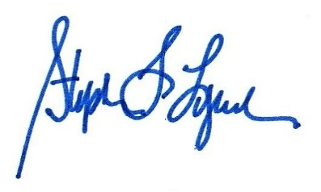
Sincerely,

_______________________

STEPHEN F. LYNCH
Member of Congress (MA-08)

cc: The Honorable Robert Garcia, Ranking Member
Committee on Oversight and Government Reform

Trump Justice Dept. Closed Investigation Into Tom Homan for Accepting Bag of Cash, New York Times (Sept. 22, 2025) (online at https://www.nytimes.com/2025/09/20/us/politics/tom-homan-fbi-trump.html).
Id.
Tom Homan was Investigated for Accepting $50,000 from Undercover FBI Agents. Trump’s DOJ Shut it Down, MSNBC (online at https://www.msnbc.com/msnbc/news/tom-homan-cash-contracts-trump-doj-investigation-rcna232568).
Id.
Id.
White House Denies Homan Took Bag of Cash in F.B.I. Inquiry, New York Times (Sept. 22, 2025) (online at https://www.nytimes.com/2025/09/22/us/politics/homan-cash.html).

